|  |  |  |
| --- | --- | --- |
| **External Document** | February 26  2015 | |
|  | | Portfolio website - Mobile BO LIU 300756885 https://github.com/alexliubj/portfolio |

Table of Contents

1. Brief Description 2

2. Nav bar 2

3. Color section 2

4. Screenshots 3

5. Wireframes 5

# Brief Description

This website contains 5 major pages.

* Home page shows my featured work, personal tagline and footer as well.
* About me shows some brief introduction of me, my relevant work experience and my education background.
* Projects showing my recent projects in table list.
* Services showing the three major services I can provide with prices in compare table
* Contact me showing contact information and a form provides the viewer who wants to contact me.

# Nav bar

Nav bar for home (non-mobile)



Nav bar for home (mobile)

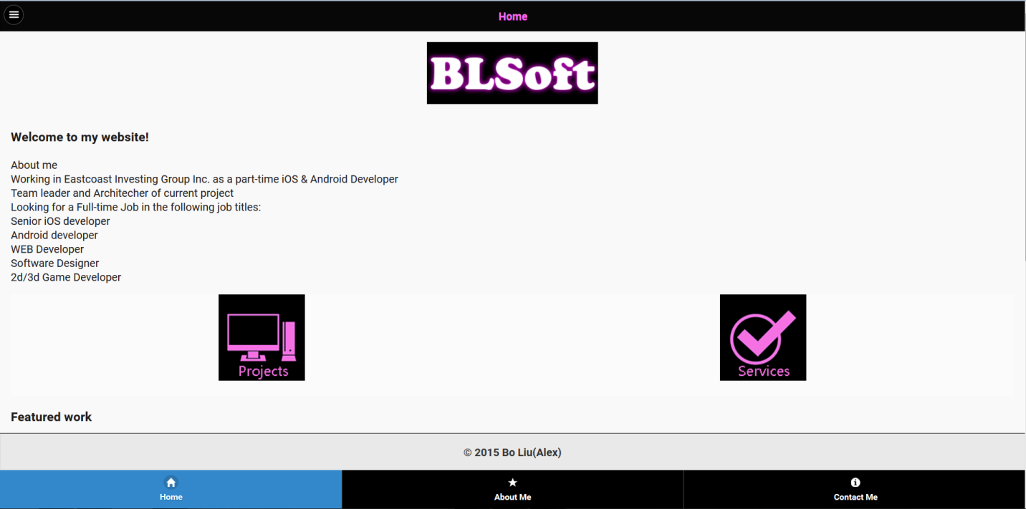

# Color section

C:\Users\AlexLiu\Desktop\2.PNG

C:\Users\AlexLiu\Desktop\3.PNG

C:\Users\AlexLiu\Desktop\4.PNG

C:\Users\AlexLiu\Desktop\6.PNG

C:\Users\AlexLiu\Desktop\7.PNG

C:\Users\AlexLiu\Desktop\8.PNG

C:\Users\AlexLiu\Desktop\9.PNG

C:\Users\AlexLiu\Desktop\1.PNG

# Screenshots

Home page:

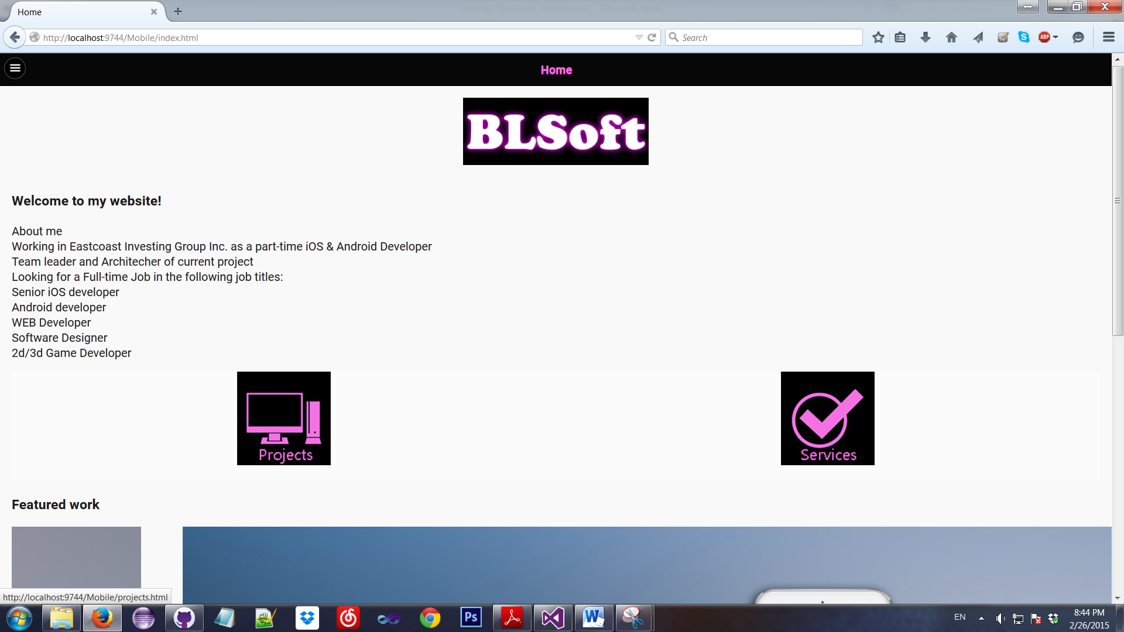

About me:

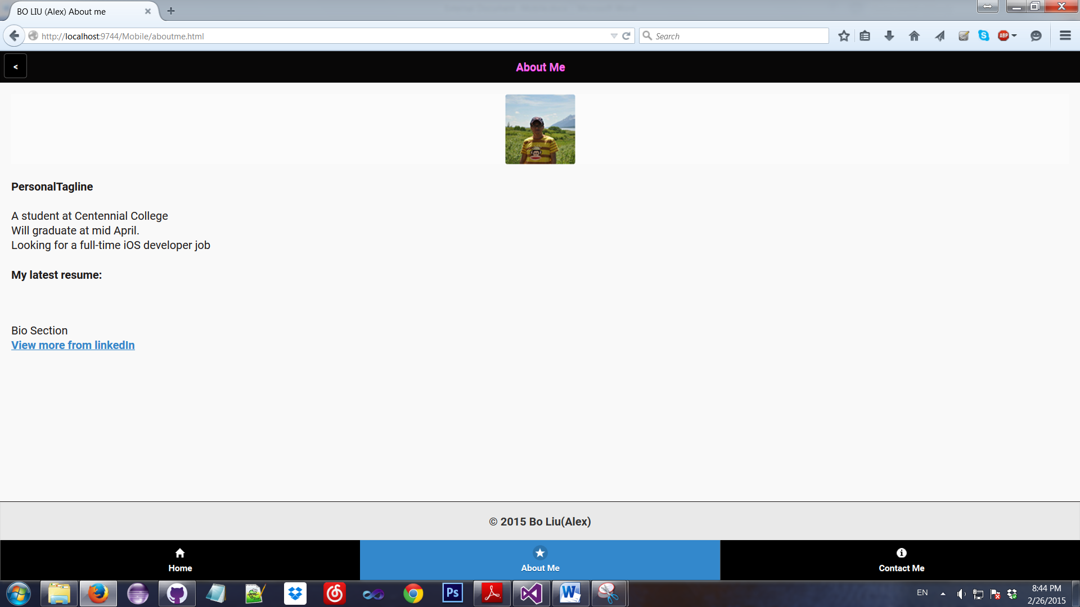

Contact me:

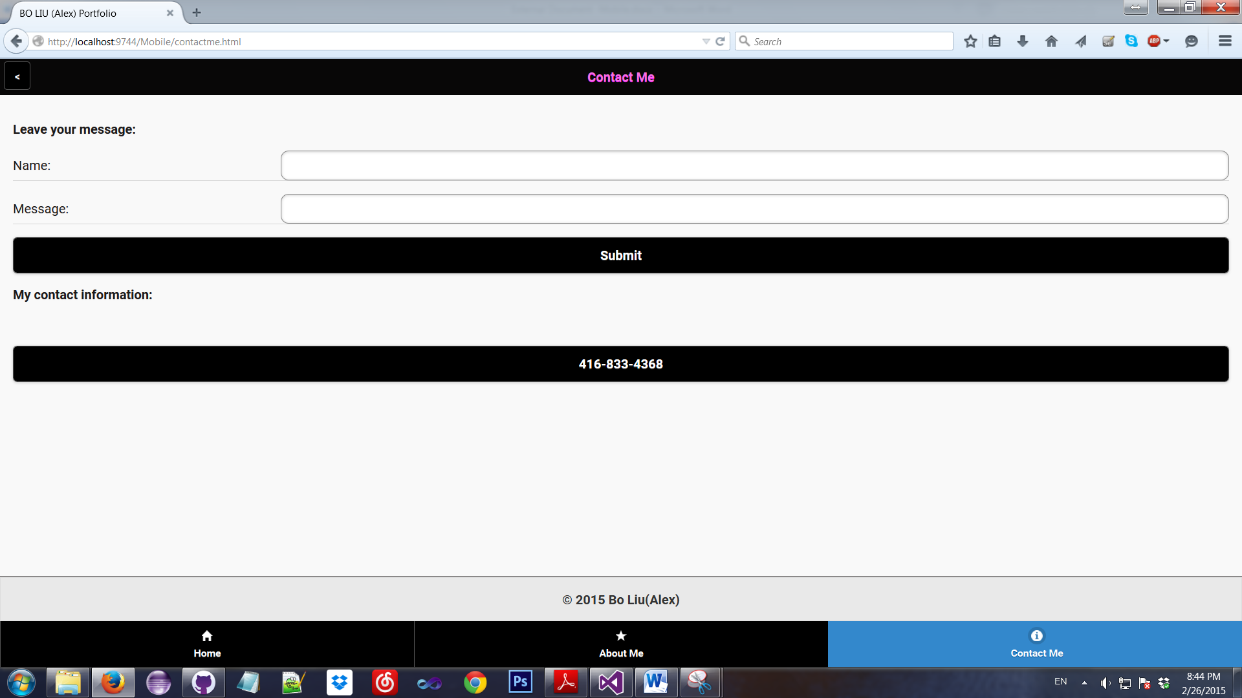

Projects:

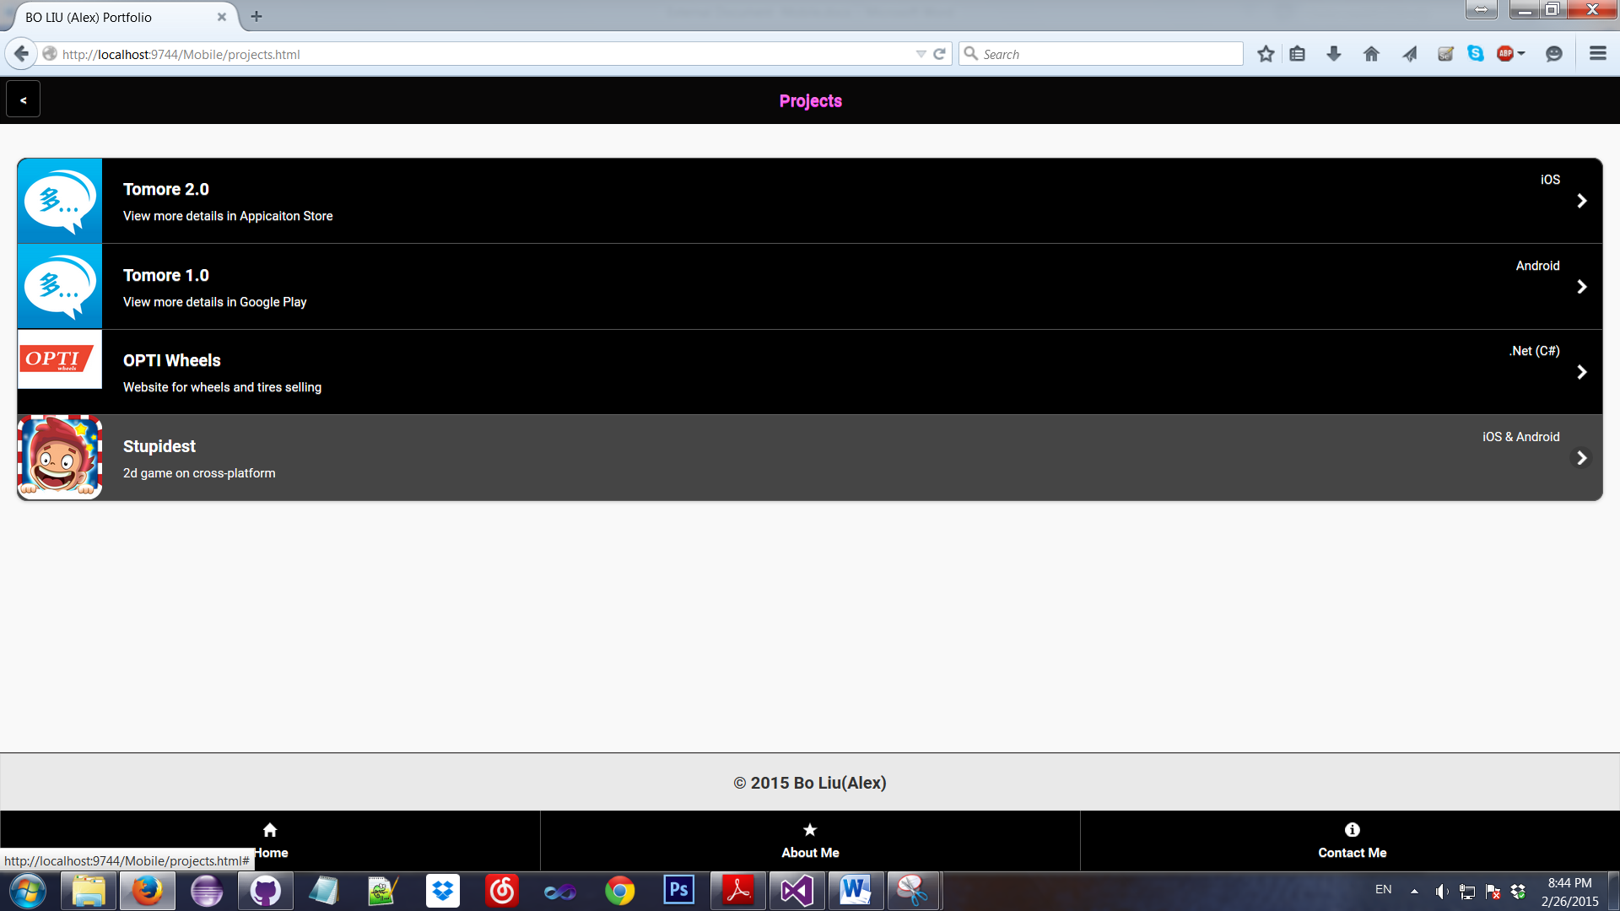

Services:

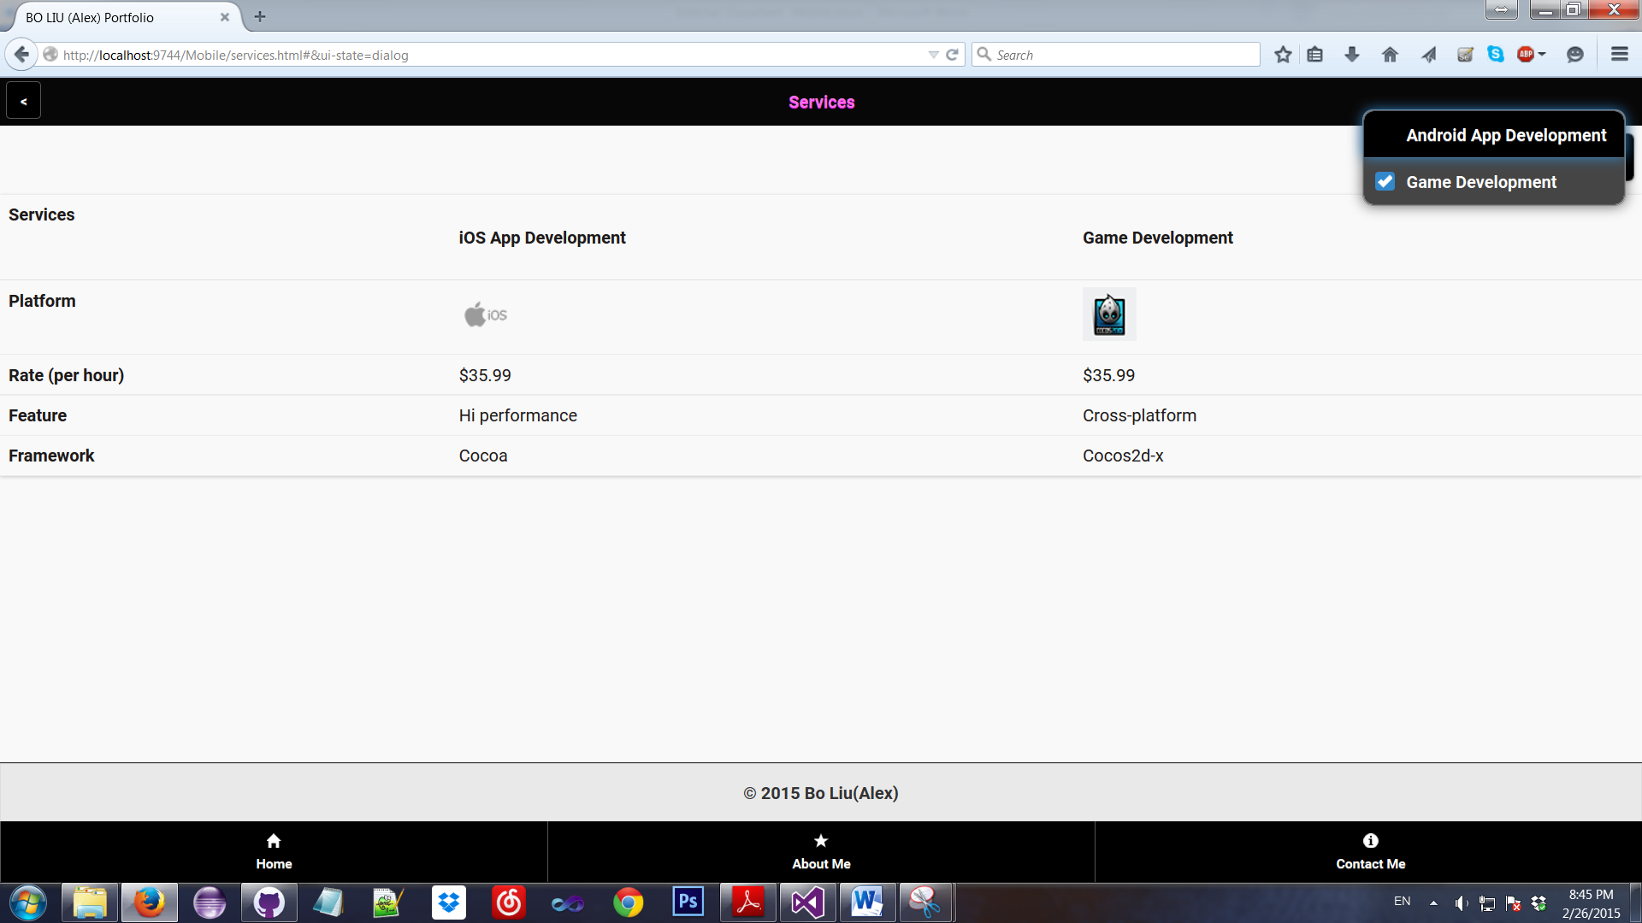

# Wireframes

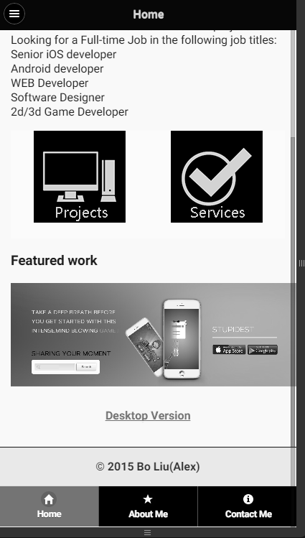

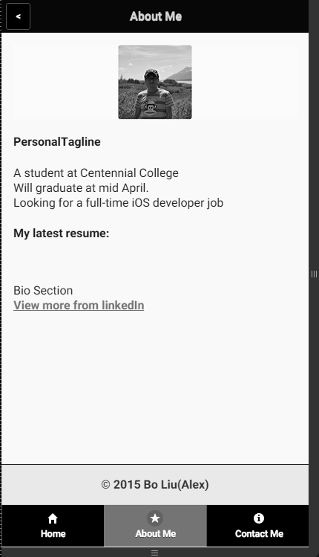

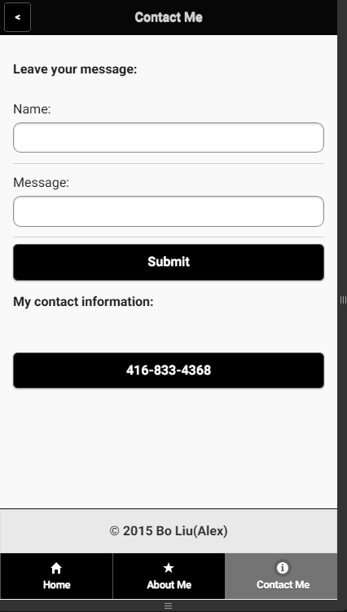

Logo

